Chapter 4, Problem 27.

Apply source transformation to find v_{x} in the circuit of Fig. 4.95.

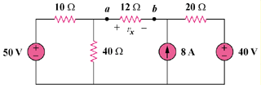

Figure 4.95
For Prob. 4.27.

